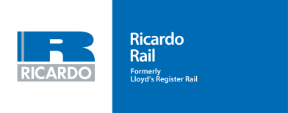

UK Graduate Scheme 2017/18

We provide our clients – train operators, manufacturers, maintenance companies, Network Rail, industry regulators etc. – with specialist technical support to help improve performance across every aspect of their operations.
Assurance and advice are central to our service portfolio. But we also provide direct access to the technologies and applications that Ricardo’s engineers have successfully brought to fields such as high-performance vehicles, mass-transit and clean energy generation for over 100 years.

Working for Ricardo Rail
Our UK rail team is looking for talented, ambitious graduates with the potential to become technical consultants and future leaders of the business.
Joining our two year Graduate Training Scheme, followed by our on-going Development Programme, will give you both the time and the opportunity to acquire a considerable industry knowledge base, while improving your practical skills.

More than technical training
From day one you can expect to be working on client projects with the support and supervision of senior colleagues.
But our programme is designed to ensure you will get all the insight you need to master your role and increase your technical knowledge of the international rail industry.
We will also devote time to help you acquire valuable client management techniques and important ‘soft’ skills – delivering presentations, project management, people management etc. – to build up your commercial strengths.

Global community
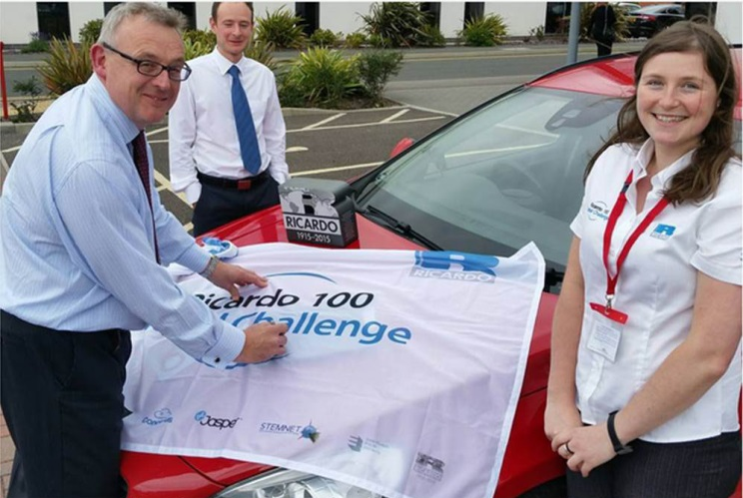
Plus, you will gain all the benefits you can expect from a career in a respected technical services organisation like Ricardo, whether that involves taking advantage of opportunities to work on international assignments; a period embedded ‘full time’ on-site within client project teams; or just by being part of a global community of engineering graduates developing their knowledge and careers together through our professional support groups.

Professional recognition
A two-year structured programme, with recognition that your development must continue beyond that, will enable you to meet the required competencies for CEng registration. Your mentor will support you in identifying needs and opportunities to ensure that this happens.

Joining our scheme
To join the Ricardo Rail UK graduate scheme you need
- To possess, or set to achieve, a Masters degree in mechanical, electro technical, aerospace or related engineering discipline.
- A genuine interest in the rail sector.
- The desire to work on a variety of projects in multidisciplinary teams.
- The ambition and confidence to become a technical consultant and a future leader.
- The conviction that you can make a real difference to peoples’ lives and their environment through your expertise.
- Strong interpersonal skills combined with client-focus and a hands-on approach.
- A drive for continuous self-development.

